Ryeish Green Sports Hub and 3G pitch
Shinfield Rangers FC user guide

Location
Hyde End Lane, Reading RG7 1ER. Signs point to “Oakbank School” as well as “Ryeish Green Sports Hub”, both of which are on the same site.
From Hyde End Road turn at the small roundabout into what appears to be the school. Go straight ahead past some parking spaces on each side of the road. The main facility car park is on the left immediately after those spaces and just before the road veers left but you can also park further up the slope in the leisure centre car park. DO NOT enter or use the school car park, which is through a second gate on the right when you entered the grounds.
The pitch itself is slightly further up the slope behind the sports hall building.

Approved footwear
Please note for both safety and pitch preservation reasons neither old-style bladed boots nor those with metal studs are allowed, nor are types of footwear with inadequate grip such as trainers or pumps/deck shoes. Boots must be CLEAN and mud-free. Generally, most moulded studs produced in the last couple of years have rounded studs on the toes, such as the pair on the bottom left of the photo, which should be fine.
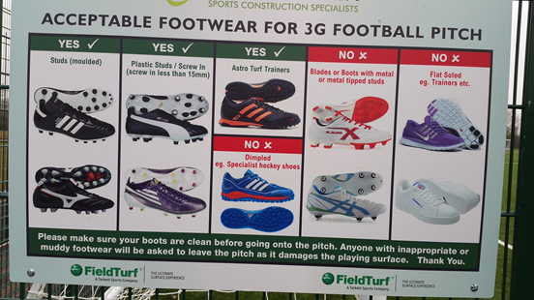

Spectators
This facility keeps to FA guidelines for 3G pitches, which means spectators are not allowed on the pitch surface. They must remain on the footpath behind the low fence barrier. Unfortunately, this is not convenient to view all matches because of the layout and is a particular design fault for some 5v5 matches. Spectators can, however, walk clockwise around the outside of the high fence and view and support through the fence. This is not ideal but its partly about reducing damage to the pitch and keeping to the Respect code.

Facilities - In the sports hall
There are toilets in the newly refurbished hall plus a few machines. Access can be gained via a door adjacent to the centre friend or approved adult gates of the 3G pitch. This is open to the public so note Safeguarding rules need to be applied.
This is a brand-new facility from which we hope to sell drinks from once things settle down.
There is a first aid room if necessary plus a defibrillator at Reception.
Litter
Please check for forgotten litter and clothing etc when you leave
Nearest Hospital
Royal Berkshire
NHS Foundation Trust
Craven Road
Reading
RG1 5AN

